User Manual

**System Administration Tool**

|  |  |
| --- | --- |
| Document Information | |
| Project Name | System Administration Tool |
| Document Version | V-1.0 |
| Author Name | Sharmin Akther |
| Verified By | Mehedi Hasan Sabuj |

Table of Contents

User Login 3

User Module 4

View / Search 4

User Add 5

User Modify: 7

# User Login

Users are able to login by browsing the application url. The root url “/” or “/index” loads a login page by which Users are able to login to the system. Users must provide their Username and Password to access the application.

* Step-1: Browse the login url (i.e. “localhost:8080/mvc/” where “localhost” is the hostname or ip address, “8080” is the port numberand “/mvc/” is the application base url.

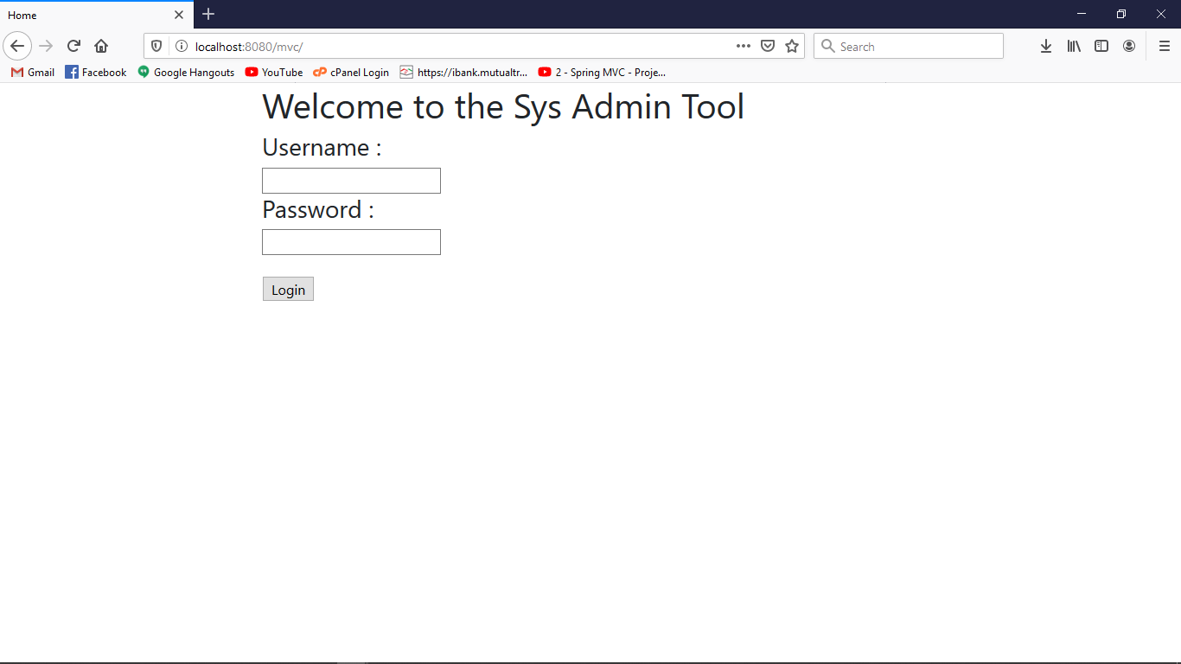.

* Step-2: Provide Username and Password. (i.e. Username : “admin”, Password : “1234”) . Then click on Login or press “Enter” button.

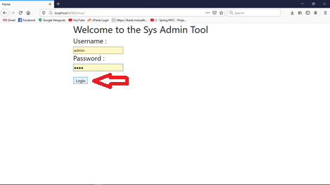

# User Module

## View / Search

Users who have permission can view the “User View / Search” only.

* Step-1: Click the button named “User View / Search” from the left side. A list of users will be shown.

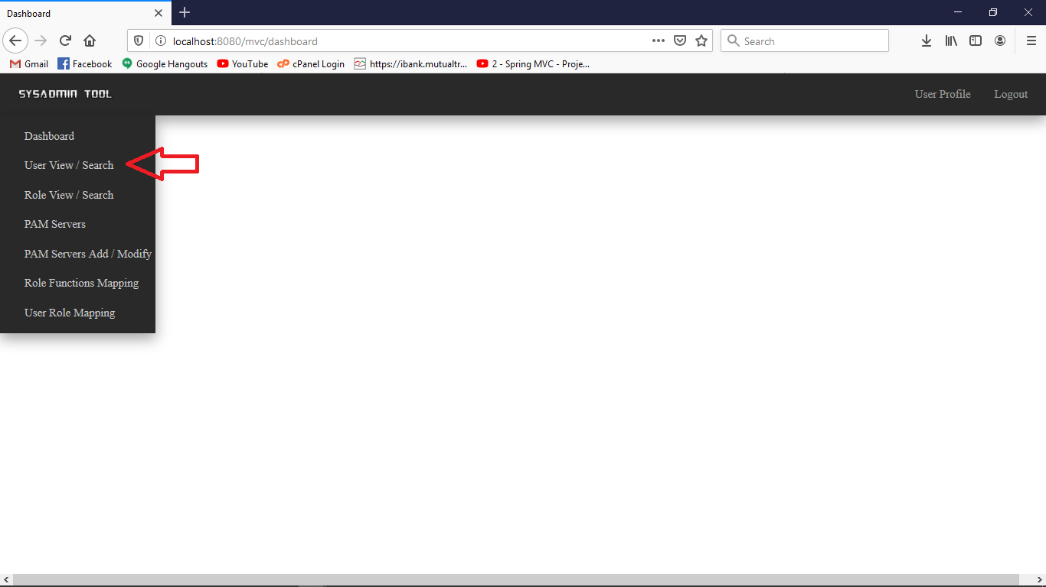

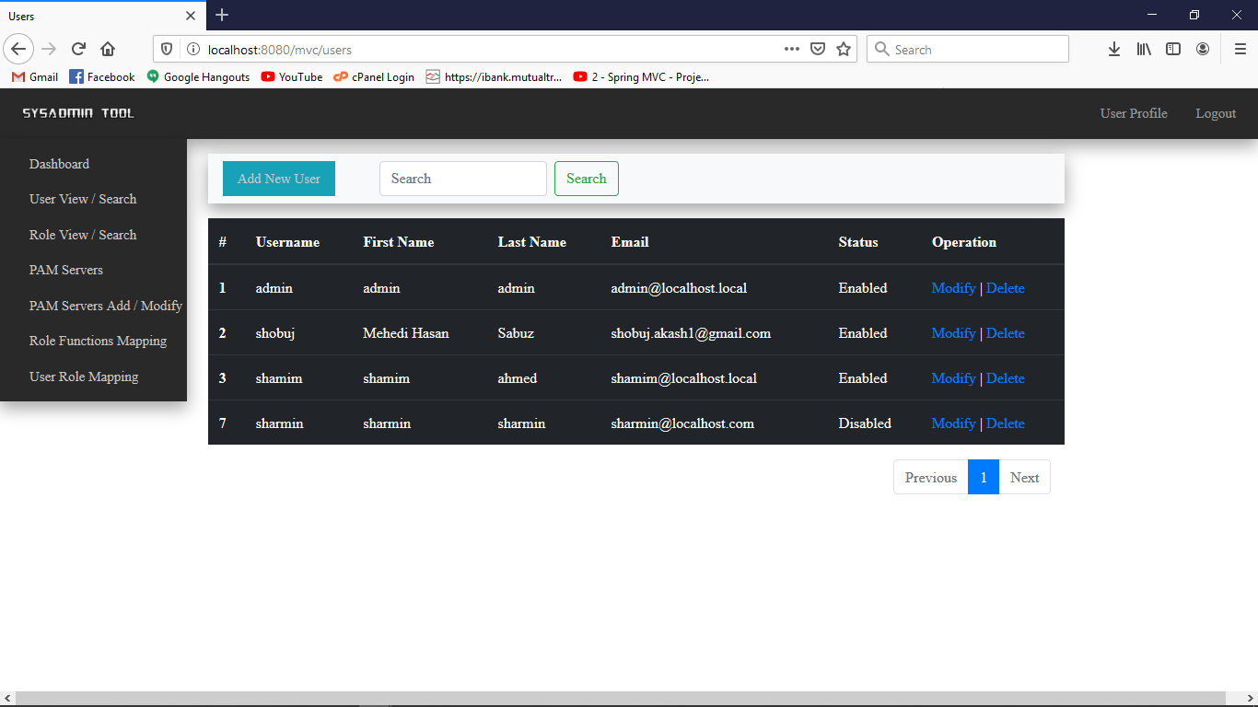

## User Add

New Users can be added into the system through the browser. Below user addition operation are provided:

* Step-1: To add new User first browse the “User View / Search” then simply click on “Add New User” button.

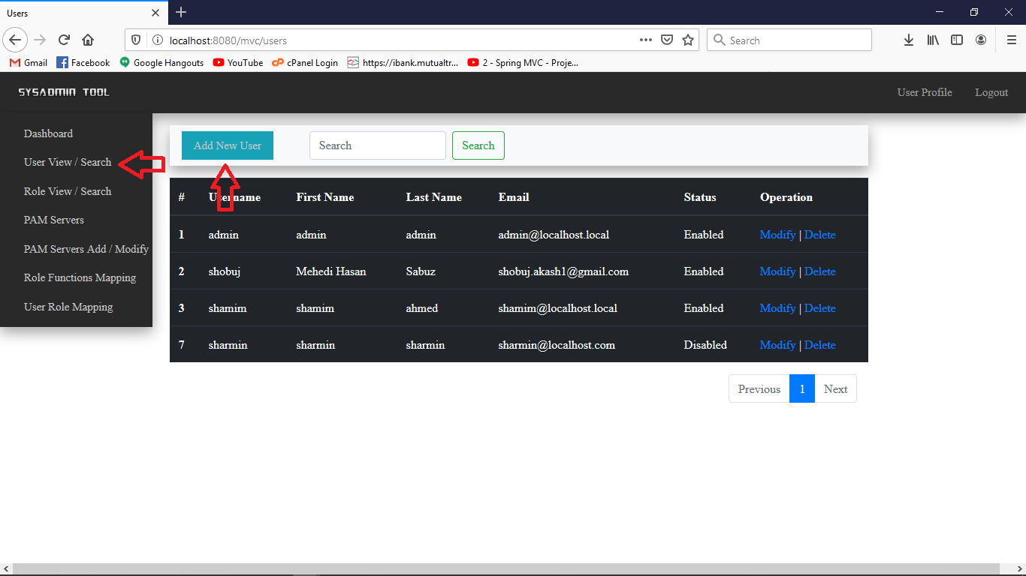

* Step-2: A new page will be loaded into the browser.
* 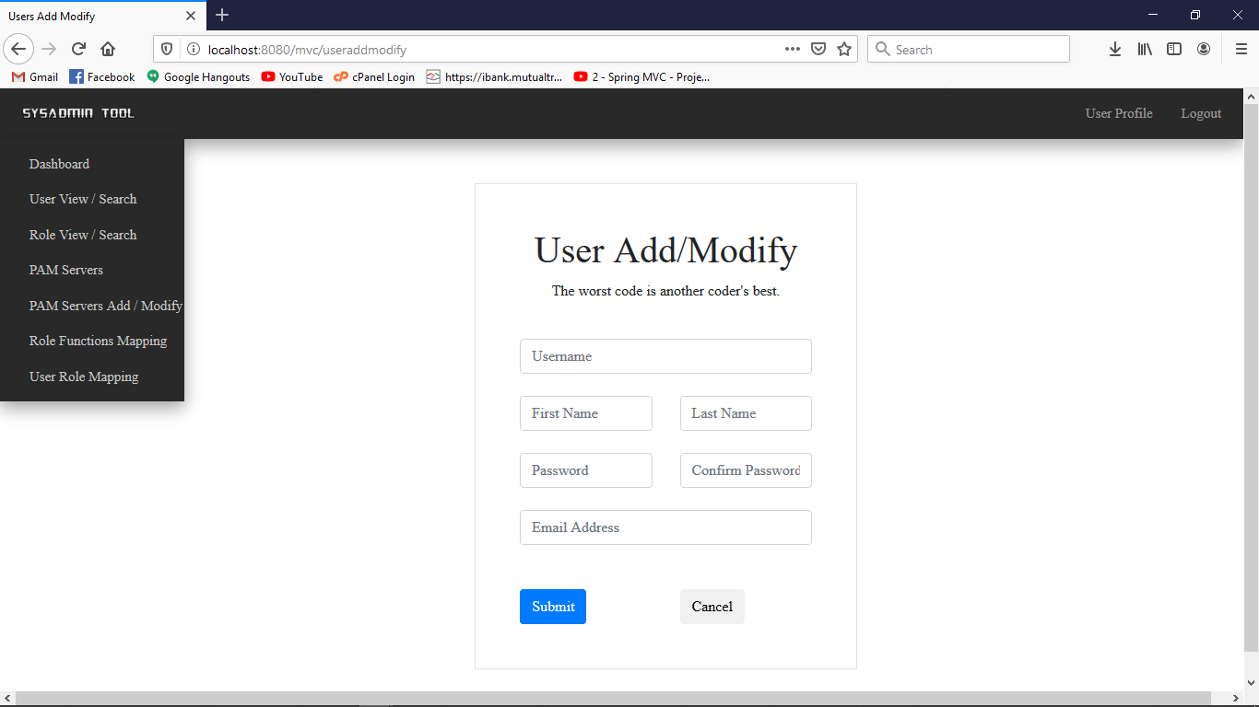
* Step-3: Fill up these input fields and then submit.

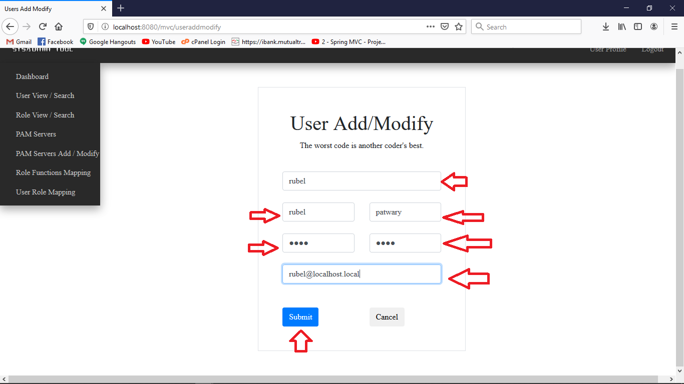

* Step-4: Click into the “User View / Search” button to view the new user which is created.

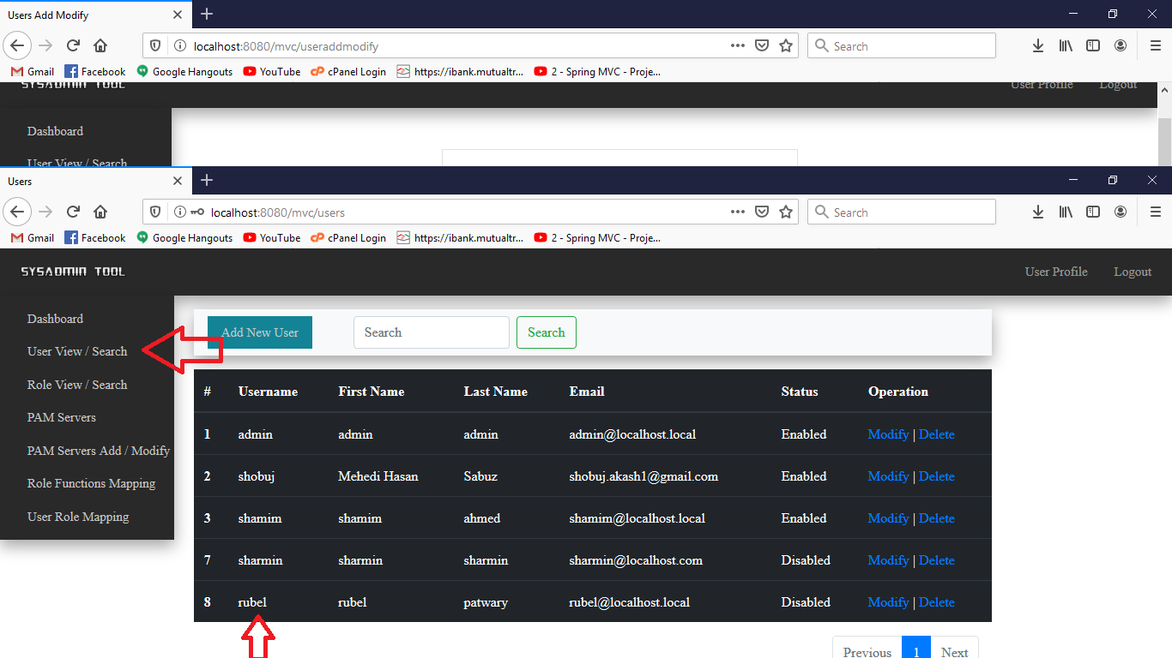

## User Modify:

Existing user information is editable by the user who have permission to modify users.

* Step-1: Click on the “User View / Search” button on the left menu bar. Then click on modify button beside the user you want to modify.

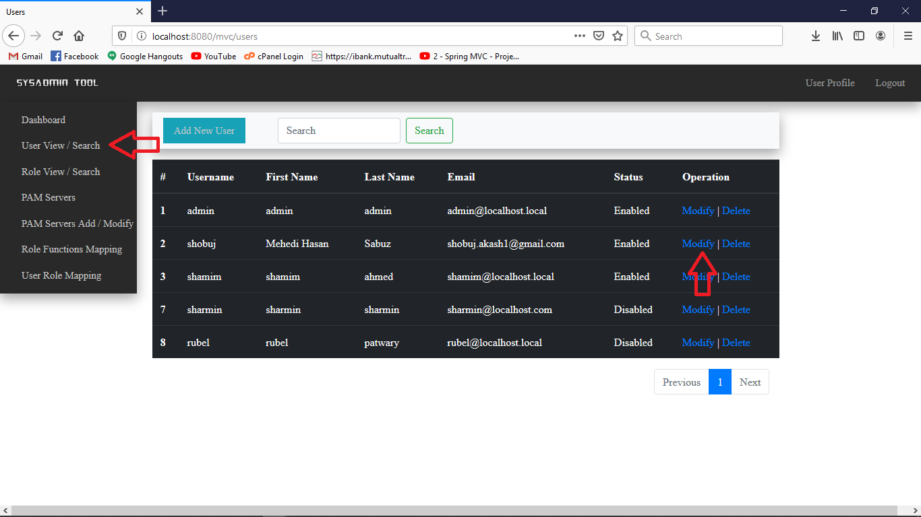

* Step-2: A new page will be loaded with the existing information of the selected user. After adding new information click on the “Submit” button to update the user information into the system.

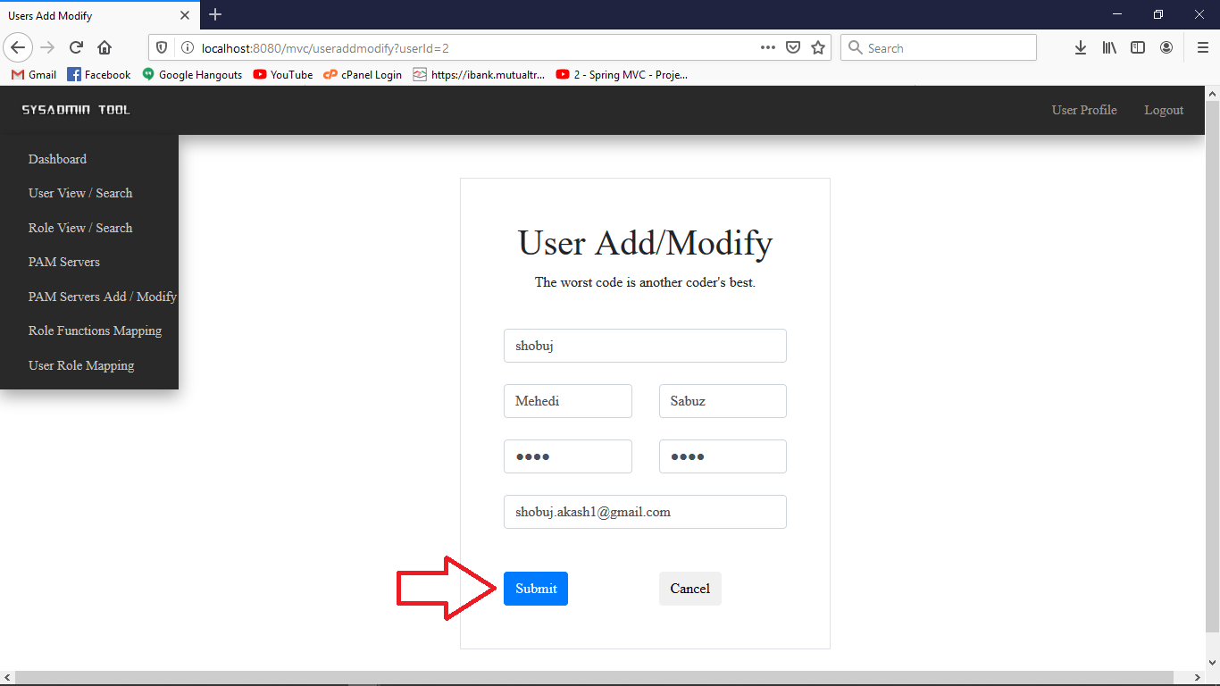

## User Delete: